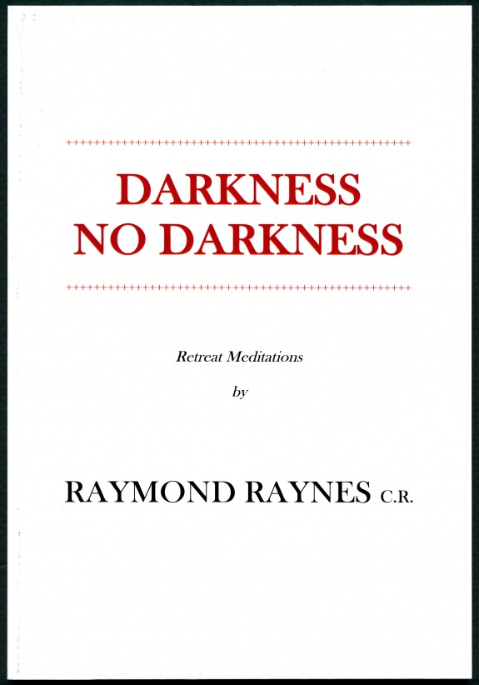
NEW RELEASE
from
The American Church Union

DARKNESS NO DARKNESS

Retreat Meditations by

RAYMOND RAYNES C.R.

Second Edition,
With kind permission of the
Community of the Resurrection, Mirfield

'This small book is written in the hope that it may help some people in the way of meditative prayer to a deeper devotion to and union with our Lord. It can be used for making a private retreat or for daily meditation . . . I have no desire to teach any new thing, and my intention is that all that is written is to be interpreted in accordance with the dogmas and doctrine of the Catholic and Apostolic Church of which, by grace, I am a member.'
Raymond Raynes C.R.
1958, Mirfield, England

76 pages, Paperback, Perfect Bound, $4.00 + shipping and handling
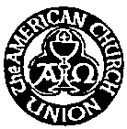
Order from:
The American Church Union, P.O. Box 40020, Berkeley, California 94704
www.AmericanChurchUnion.com, 510-841-3083
Group discounts available, online ordering now available

